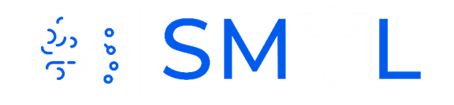
The Autism Certificate of Excellence
“Rethinking Autism from the Science Technology Engineering, Arts and Math Perspective”

The last decade has seen an acceleration in scientific and technological discoveries across brain sciences explaining underlying causes of phenomena at many different levels of inquiry. In tandem, various fields have leveraged these discoveries and created supporting technologies that accommodate and improve the quality of life of people with neurological conditions that we now know overlap with autism. Despite these various scientific and technological revolutions, parents, educators, first responders and clinicians providing services to the autistic community, have yet to benefit from this new body of knowledge. We will be missing an incredible opportunity if we do not bring everyone up to speed on science, technology, engineering, and math, to learn about the research advances of the 21st Century.
The Autism Certificate of Excellence by the Rutgers University Professor Torres’ Sensory Motor Integration Lab, will empower people to empower people on the spectrum of autism. By educating all stakeholders in the complex autism ecosystem, we will build a new perception of autism and help integrate autistic individuals as active, contributing members of our society.
The certificate has 4 courses with 3 modules each and is built on a tier system whereby, tier 1 is basic knowledge and tiers 2 and 3 build on complexity according to the professional demands of the person.

Acknowledgement: This Certificate is funded in part by the Governor’s Council Grant to Prof. EBT, NJACE 2018-2023, by the Nancy Lurie Marks Family Foundation Early Career Award to Prof. EBT and by the Rutgers University School of Arts and Science funding Prof. EBT lab’s students and postdoctoral fellows who donated their time to build it.
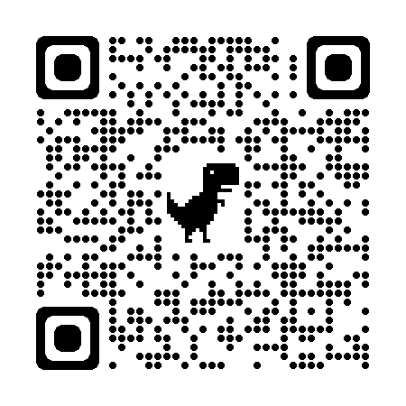
Contact Professor Elizabeth B Torres, PhD – ebtorres@psych.rutgers.edu
Visit our website

